AWS S3 – Amazon Simple Storage Service
Amazon S3 is one of the main building blocks of AWS
Many AWS services use Amazon S3 as an integration

S3 Use cases
- Backup and storage
- Disaster Recovery
- Archive
- Hybrid Cloud storage
- Application hosting
- Media hosting
- Data lakes & big data analytics
- Software delivery
- Static website

S3 – Buckets
- Amazon S3 allows people to store objects (files) in “buckets” (directories)
- Buckets must have a globally unique name (across all regions all accounts)
- Buckets are defined at the region level
- S3 looks like a global service but buckets are created in a region
- Naming convention
  - No uppercase, No underscore
  - 3-63 characters long
  - Not an IP
  - Must start with lowercase letter or number
  - Must NOT start with the prefix xn--
  - Must NOT end with the suffix -s3alias

S3 – Objects
• Objects (files) have a Key
• The key is the FULL path:
• s3://my-bucket/my_file.txt
• s3://my-bucket/my_folder1/another_folder/my_file.txt
• The key is composed of prefix + object name
• s3://my-bucket/my_folder1/another_folder/my_file.txt
• There’s no concept of “directories” within buckets (although the UI will trick you to think otherwise)
• Just keys with very long names that contain slashes (“/”)
• Object values are the content of the body:
• Max. Object Size is 5TB (5000GB)
• If uploading more than 5GB, must use “multi-part upload”
• Metadata (list of text key / value pairs – system or user metadata)
• Tags (Unicode key / value pair – up to 10) – useful for security / lifecycle
• Version ID (if versioning is enabled)

S3 – Security (important)
• User-Based
• IAM Policies – which API calls should be allowed for a specific user from IAM
• Resource-Based
• Bucket Policies – bucket wide rules from the S3 console - allows cross account to access your bucket
• Object Access Control List (ACL) – finer grain (can be disabled)
• Bucket Access Control List (ACL) – less common (can be disabled)
• Note: an IAM principal can access an S3 object if
• The user IAM permissions ALLOW it OR the resource policy ALLOWS it
• AND there’s no explicit DENY
• Encryption: encrypt objects in Amazon S3 using encryption keys

S3 – Bucket Policies

• JSON based policies
• Resources: buckets and objects
• Effect: Allow / Deny
• Actions: Set of API to Allow or Deny
• Principal: The account or user to apply the
policy to
• Use S3 bucket for policy to:
• Grant public access to the bucket
• Force objects to be encrypted at upload
• Grant access to another account (Cross
Account)
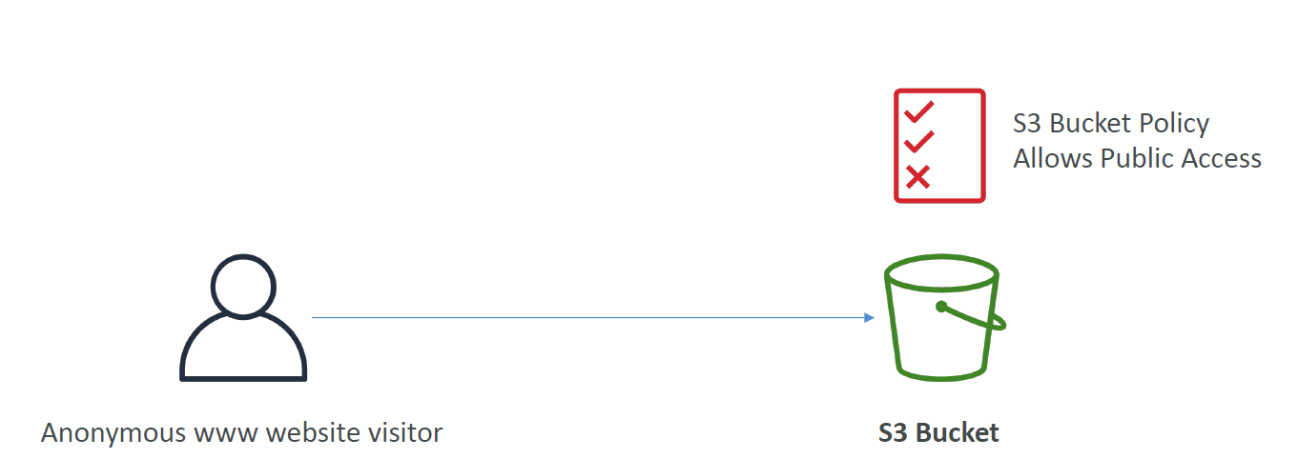
Scenario: User on the internet want to access to the objects within S3 Bucket. So we attach S3 Bucket Policy allow Public access for user able to access S3 bucket

Example: Alternative Allow User access to S3 using IAM Permission that allow that IAM user access to S3 Bucket
Example: Allow EC2 instance access to S3 Bucket using IAM Roles
Explain: Since attach IAM User policies to an EC2 instance is not suitable. We need to use and create Role with enough IAM permissions for that role instead that attach that IAM Role the EC2 instance.
Thus allows EC2 instance able to access S3 Bucket
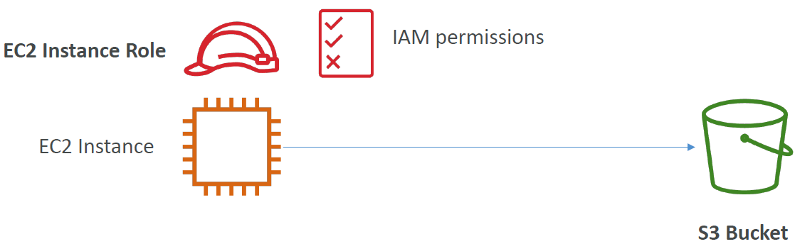
Advance: Cross-Account access using Bucket Policy
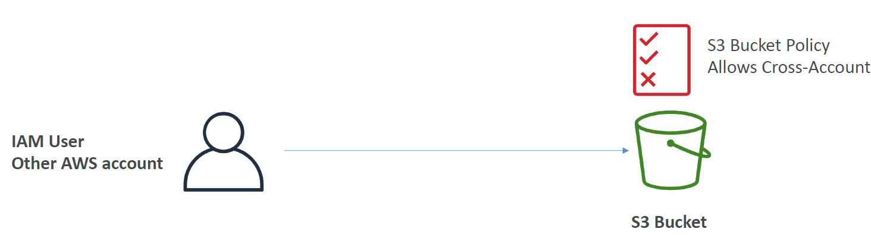
Bucket settings for Block Public Access
• These settings were created to prevent company data leaks
• If you know your bucket should never be public, leave these on
• Can be set at the account level
S3 – Bucket Policies – Hands-on

First Create a Bucket
In Bucket Policy > Policy generator
In Policy generator
Step 1: Select policy type: S3 Bucket Policy
Step 2: Add Statement(s)
Effect: Select Allow or Deny
Principal: * (for allow all)
AWS service: Amazon S3
Actions: GetObject
Amazon resource name (ARN):
Syntax: ARN should follow the following format: arn:aws:s3:::${BucketName}/${KeyName}.
Use a comma to separate multiple values.
So we will input: arn:aws:s3:::dduckhang-sa-bucket/the_file_to_allow
In this case we allow User to read all Objects within the bucket
Therefore the syntax of ARN will be: arn:aws:s3:::dduckhang-sa-bucket/*
Step 3: generate policy
Press generate policy will pop up Policy JSON syntax. Copy it then paste into Bucket Policy section
{
"Id": "Policy1730889327048",
"Version": "2012-10-17",
"Statement": [
{
"Sid": "Stmt1730889307873",
"Action": [
"s3:GetObject"
],
"Effect": "Allow",
"Resource": "arn:aws:s3:::dduckhang-sa-bucket/*",
"Principal": "*"
}
]
}
Translate the JSON mean:
This Policy “Effect” to “Allow” anyone (Principal) to access and read/get any object within this bucket (Resource)
Result now Users can access and View and Download the file through it URL https://dduckhang-sa-bucket.s3.ap-southeast-1.amazonaws.com/kinh-nghiem-du-lich-ha-long-1_1674039271.jpg

S3 – Static Website Hosting
• S3 can host static websites and have them accessible on the Internet
• The website URL will be (depending on the region)
• http://bucket-name.s3-website-aws-region.amazonaws.com
OR
• http://bucket-name.s3-website.aws-region.amazonaws.com
• If you get a 403 Forbidden error, make sure the bucket policy allows public reads!
S3 – Static Web Hosting Hands-on
Prerequisites: You must make all content on your website public accessible
Go to S3 bucket > Properties tab > Scroll down to Static Website Hosting section
Static website hosting: Enable
Index document: Input the HTML file you want to display
Error document – optional: Input the error HTML file you want to display
Finally Save changes and upload Index.html file to the bucket

Index.html
<!DOCTYPE html>
<html lang="en">
<head>
<meta charset="UTF-8">
<meta name="viewport" content="width=device-width, initial-scale=1.0">
<title>Document</title>
</head>
<body>
<h1>This is static website hosted by AWS S3</h1>
<p>DEMO</p>
<img src="https://dduckhang-sa-bucket.s3.ap-southeast-1.amazonaws.com/kinh-nghiem-du-lich-ha-long-1_1674039271.jpg" width="1200px" height="900px">
</body>
</html>

Result
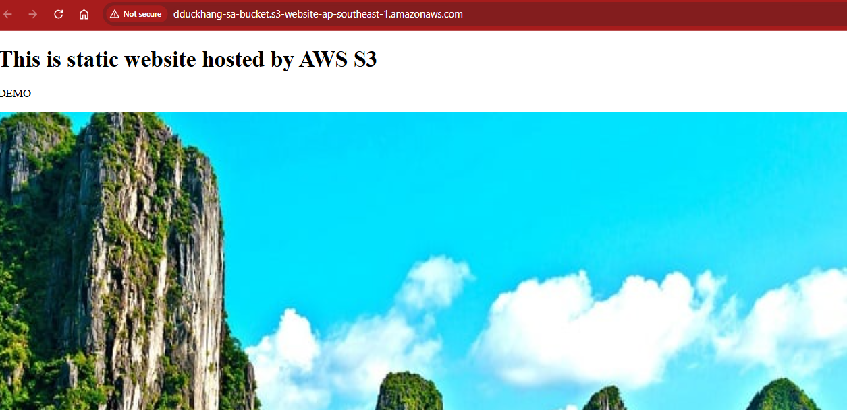

S3 – Versioning
• You can version your files in Amazon S3
• It is enabled at the bucket level
• Same key overwrite will change the “version”: 1, 2, 3….
• It is best practice to version your buckets
• Protect against unintended deletes (ability to restore a version)
• Easy roll back to previous version
• Notes:
• Any file that is not versioned prior to enabling versioning will have version “null”
• Suspending versioning does not delete the previous versions

S3 – Replication (Cross-Region Replication & Same Region Replication)
- Must enable versioning in source and destination buckets
- Buckets can be in different AWS accounts
- Copying is asynchronous
- Must give proper IAM permissions to S3
- Use case:
  - CRR – compliance, lower latency access, replication across accounts
  - SRR – log aggregation, live replication between production and test accounts
Replication Notes

• After you enable Replication, only new objects are replicated
• Optionally, you can replicate existing objects using S3 Batch Replication
• Replicates existing objects and objects that failed replication
• For DELETE operations
• Can replicate delete markers from source to target (optional setting)
• Deletions with a version ID are not replicated (to avoid malicious deletes)
• There is no “chaining” of replication
• If bucket 1 has replication into bucket 2, which has replication into bucket 3
• Then objects created in bucket 1 are not replicated to bucket 3

S3 – Replication Hands-on
In S3 Bucket > Management > Replication rule > Replication rule
Set Replication rule name
Choose a rule scope
Limit the scope of this rule using one or more filters
Apply to all objects in the bucket (Pick this one)
bucket name: Select the bucket you want to Replicate (The bucket must a different destination bucket aka not the same bucket you using to create Replication or “source bucket”
IAM ROLE:
Create new role (select this one)
Choose from existing IAM roles
Enter IAM role ARN
After that if you upload anything to your Source Bucket it will be replicated to destination bucket as well.
Example:
Source bucket
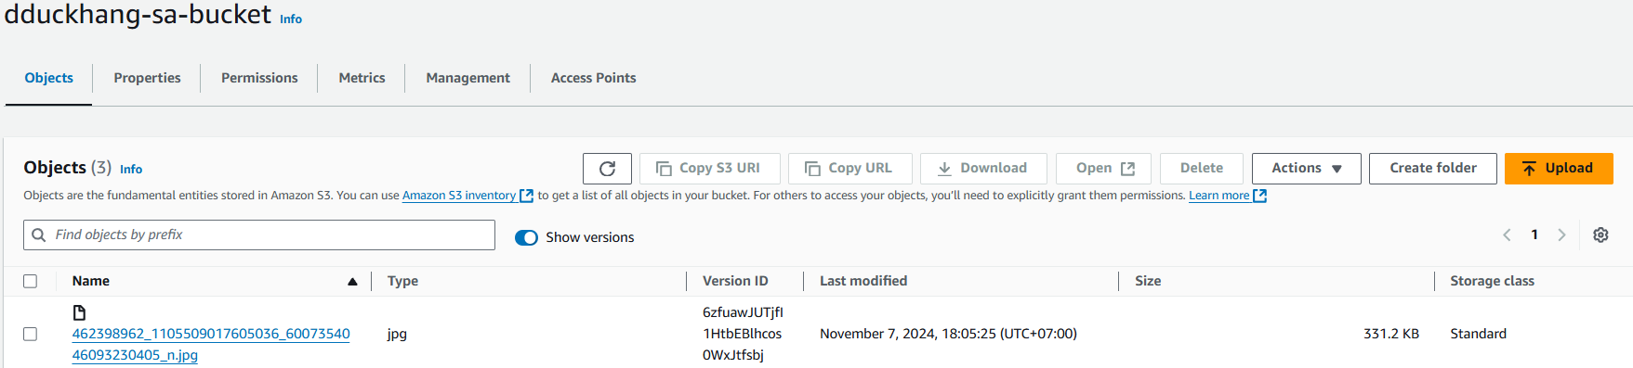

Destination bucket
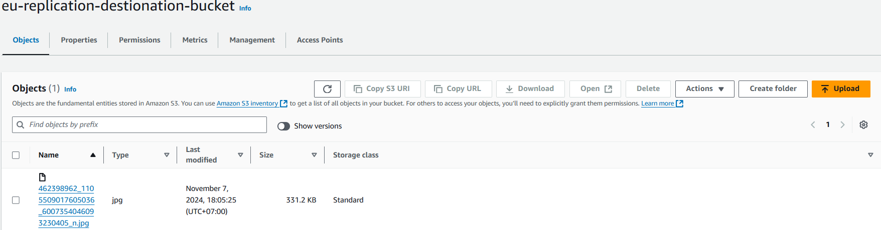
To give “delete marker” to replication objects upon Source Bucket’s version objects being deleted:
Management > Edit rule > Additional replication options > Enable Delete marker replication

S3 – Storage Classes
• Amazon S3 Standard - General Purpose
• Amazon S3 Standard-Infrequent Access (IA)
• Amazon S3 One Zone-Infrequent Access
• Amazon S3 Glacier Instant Retrieval
• Amazon S3 Glacier Flexible Retrieval
• Amazon S3 Glacier Deep Archive
• Amazon S3 Intelligent Tiering
• Can move between classes manually or using S3 Lifecycle configurations

S3 Durability and Availability
• Durability:
• High durability (99.999999999%, 11 9’s) of objects across multiple AZ
• If you store 10,000,000 objects with Amazon S3, you can on average expect to
incur a loss of a single object once every 10,000 years
• Same for all storage classes
• Availability:
• Measures how readily available a service is
• Varies depending on storage class
• Example: S3 standard has 99.99% availability = not available 53 minutes a year

S3 Standard – General Purpose
• 99.99% Availability
• Used for frequently accessed data
• Low latency and high throughput
• Sustain 2 concurrent facility failures
• Use Cases: Big Data analytics, mobile & gaming applications, content
distribution…

S3 Storage Classes – Infrequent Access
• For data that is less frequently accessed, but requires rapid access when needed
• Lower cost than S3 Standard
• Amazon S3 Standard-Infrequent Access (S3 Standard-IA)
• 99.9% Availability
• Use cases: Disaster Recovery, backups
• Amazon S3 One Zone-Infrequent Access (S3 One Zone-IA)
• High durability (99.999999999%) in a single AZ; data lost when AZ is destroyed
• 99.5% Availability
• Use Cases: Storing secondary backup copies of on-premises data, or data you can recreate

Amazon S3 Glacier Storage Classes
• Low-cost object storage meant for archiving / backup
• Pricing: price for storage + object retrieval cost
• Amazon S3 Glacier Instant Retrieval
• Millisecond retrieval, great for data accessed once a quarter
• Minimum storage duration of 90 days
• Amazon S3 Glacier Flexible Retrieval (formerly Amazon S3 Glacier):
• Expedited (1 to 5 minutes), Standard (3 to 5 hours), Bulk (5 to 12 hours) – free
• Minimum storage duration of 90 days
• Amazon S3 Glacier Deep Archive – for long term storage:
• Standard (12 hours), Bulk (48 hours)
• Minimum storage duration of 180 days

S3 Intelligent-Tiering
• Small monthly monitoring and auto-tiering fee
• Moves objects automatically between Access Tiers based on usage
• There are no retrieval charges in S3 Intelligent-Tiering
• Frequent Access tier (automatic): default tier
• Infrequent Access tier (automatic): objects not accessed for 30 days
• Archive Instant Access tier (automatic): objects not accessed for 90 days
• Archive Access tier (optional): configurable from 90 days to 700+ days
• Deep Archive Access tier (optional): config. from 180 days to 700+ days

S3 Storage Classes Comparison
https://aws.amazon.com/s3/storage-classes/

S3 Storage Classes – Price Comparison
Example: us-east-1
https://aws.amazon.com/s3/pricing/

QA
Question 2:
You have enabled versioning in your S3 bucket which already contains a lot of files. Which version will the existing files have?
Answer: null
Explain: those files exist prior to the time you enable versioning in S3 will have “null” version as default setting.
Question 3:
You have updated an S3 bucket policy to allow IAM users to read/write files in the S3 bucket, but one of the users complain that he can't perform a PutObject API call. What is a possible cause for this?
Answer: Explicit DENY in an IAM Policy will take precedence over an S3 bucket policy.
Question 4:
You want the content of an S3 bucket to be fully available in different AWS Regions. That will help your team perform data analysis at the lowest latency and cost possible. What S3 feature should you use?
Answer: S3 Replication
Explain: S3 replication allow both Cross-Region Replication and Same Region replication
Question 5:
You have 3 S3 buckets. One source bucket A, and two destination buckets B and C in different AWS Regions. You want to replicate objects from bucket A to both bucket B and C. How would you achieve this?
Answer: Configure replication from bucket A to bucket B, then from bucket A to bucket C
Explain: Because bucket A is source bucket it can replicate to what ever bucket you want to. On top of that, you can not use replication from a destination bucket to another bucket
Which of the following is NOT a Glacier Deep Archive retrieval mode?
Answer: Expedited(1-5 minutes) This is not a tier in S3 Glacier Deep Archive
Question 7:
Which of the following is NOT a Glacier Flexible retrieval mode?
Answer: Instant because it’s not a real tier in S3 Glacier Flexible retrieval

